Central Luzon State University

 College of Engineering

 Bachelor of Science in Information Technology

[**INTECH 2100**](https://classroom.google.com/u/0/c/NTM4NTU5NjI4ODE0)

Pizza.co

Maniquis, Jayzer Joseph (Individual)

**Overview**

This website is a restaurant theme website. A pizza parlor to be specific. This website contains the brief history, menu/full menu of different pizzas and dessert, different locations of the store and a page to contact the restaurant.

**Home/navigation bar**

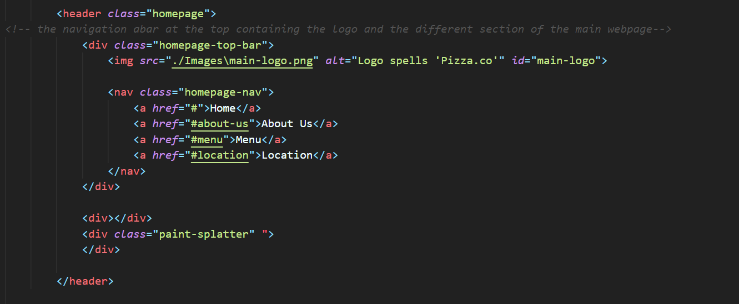

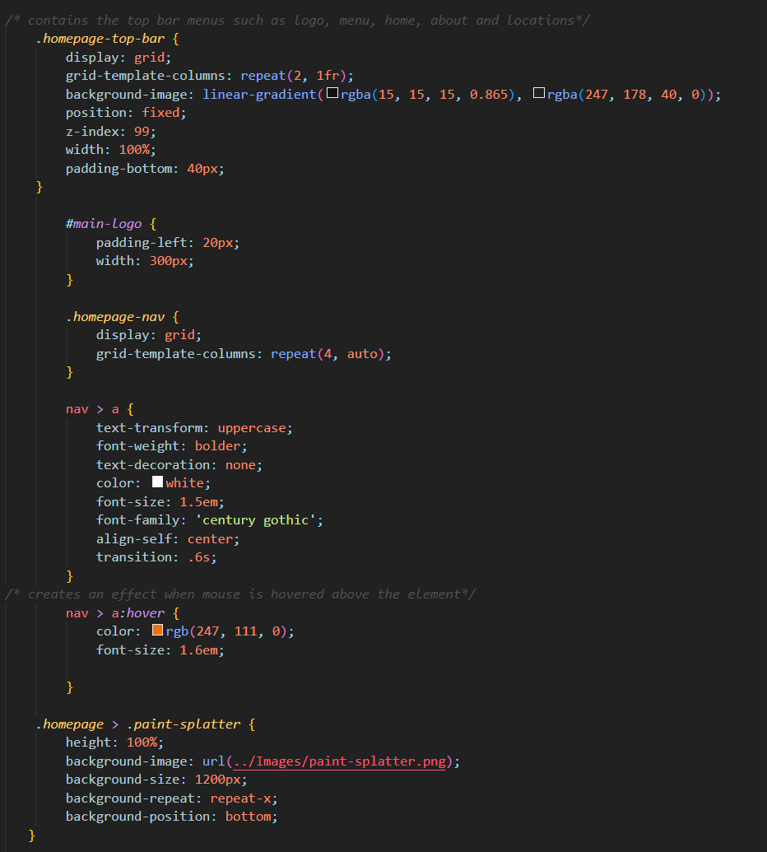

This contains the navigation bar and is the same throughout the different webpages. Uses a fixed position so it stays fixed even the page is being scrolled. Uses grid to layout the different buttons and images.

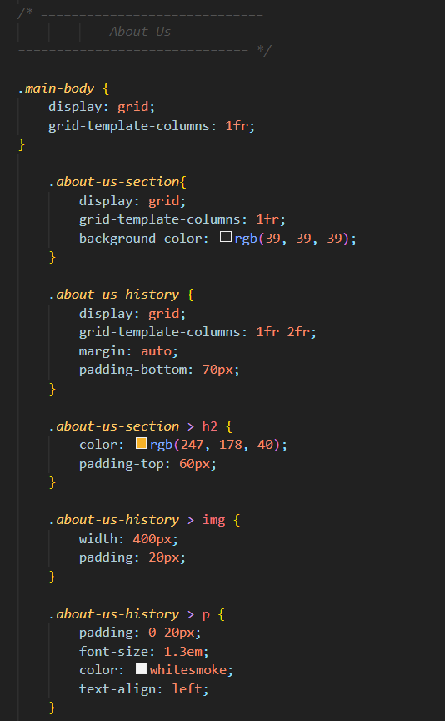**Main body > about**

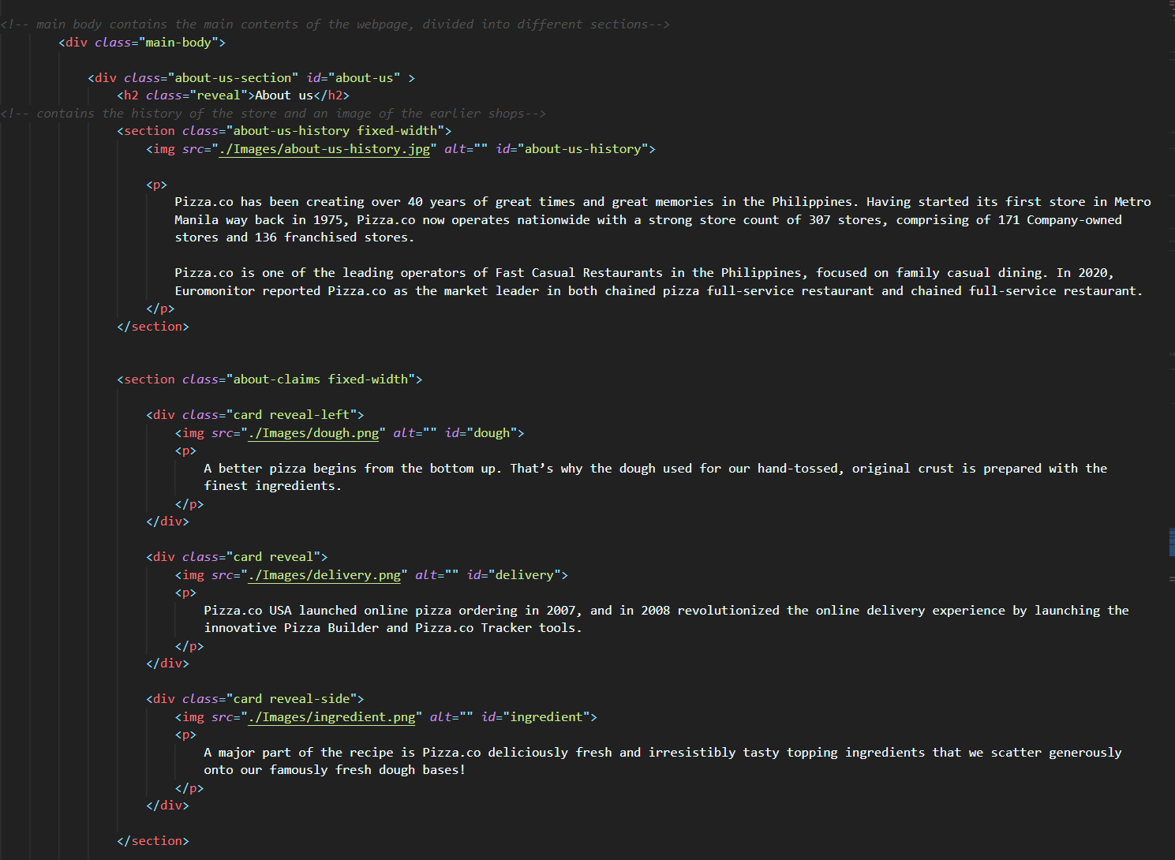

Contains the brief history of the pizza parlor and some service claims, uses grid to layout the different sections and images.

**Main body > JavaScript classes (CSS)**

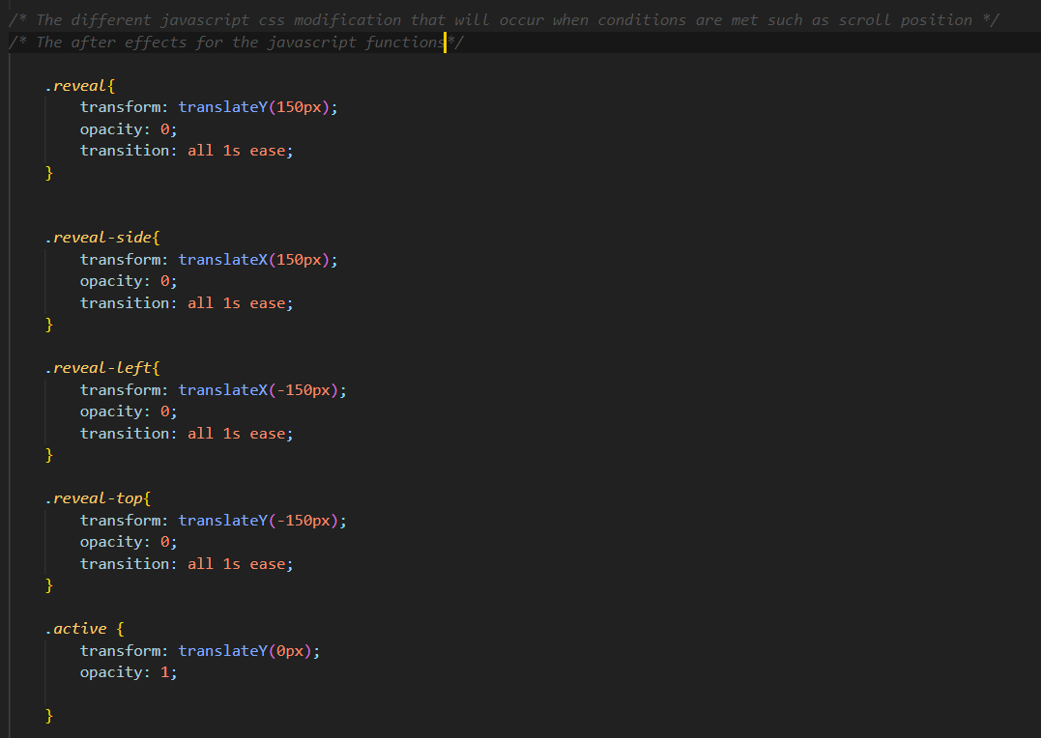

This portion of the CSS is the configuration for the JavaScript’s functions, Mainly the before and after styles.

**Main body > menu**

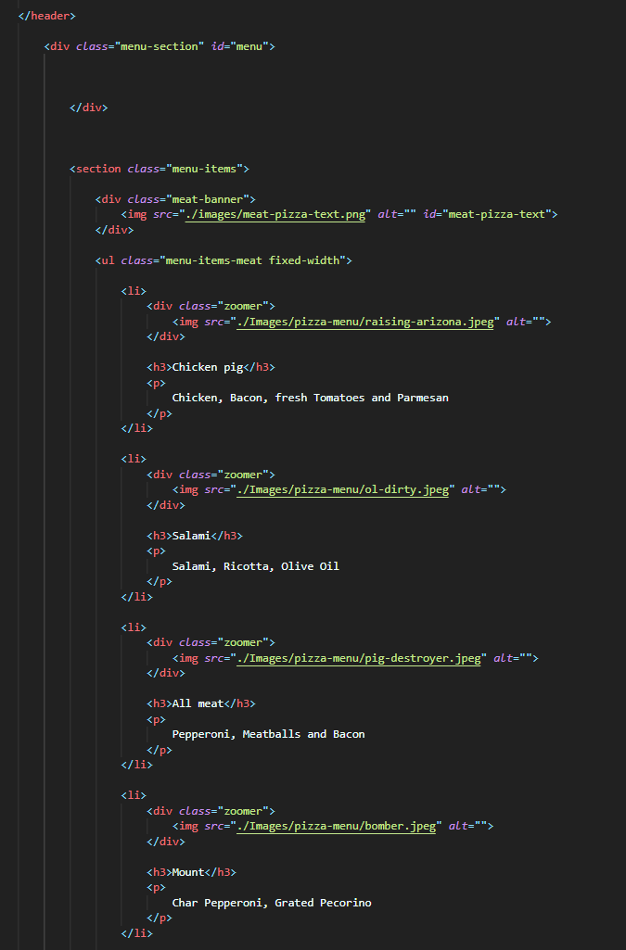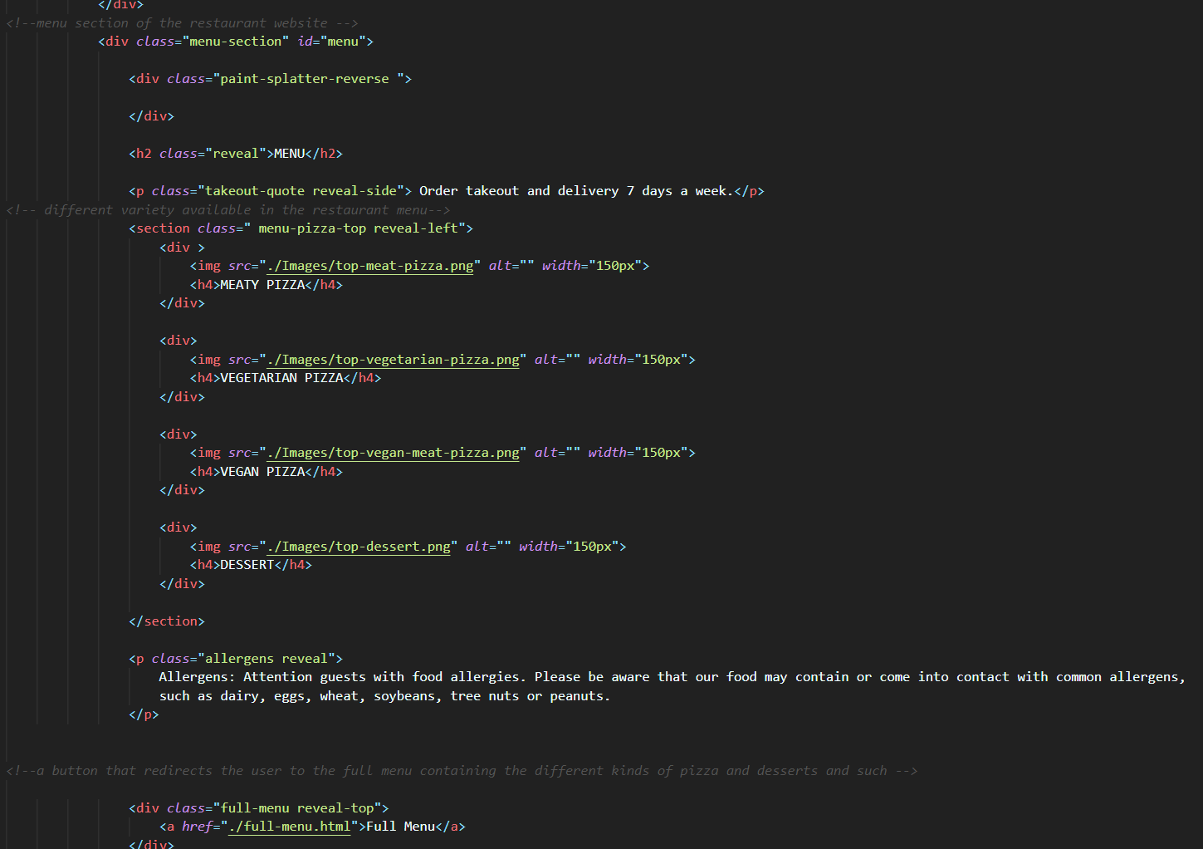

This is where the different kinds of pizza and cautions are presented. The other webpage contains the specific menu for the different pizzas and dessert.

This contains the specific menus and its description. Compiled inside its own webpage. Through the use of CSS’s overflow hidden the zoom effect for the pizza menu was achieved. And background fixed allows the pizza banner to have a parallax effect to it when scrolled down or up.

**Main body > location**

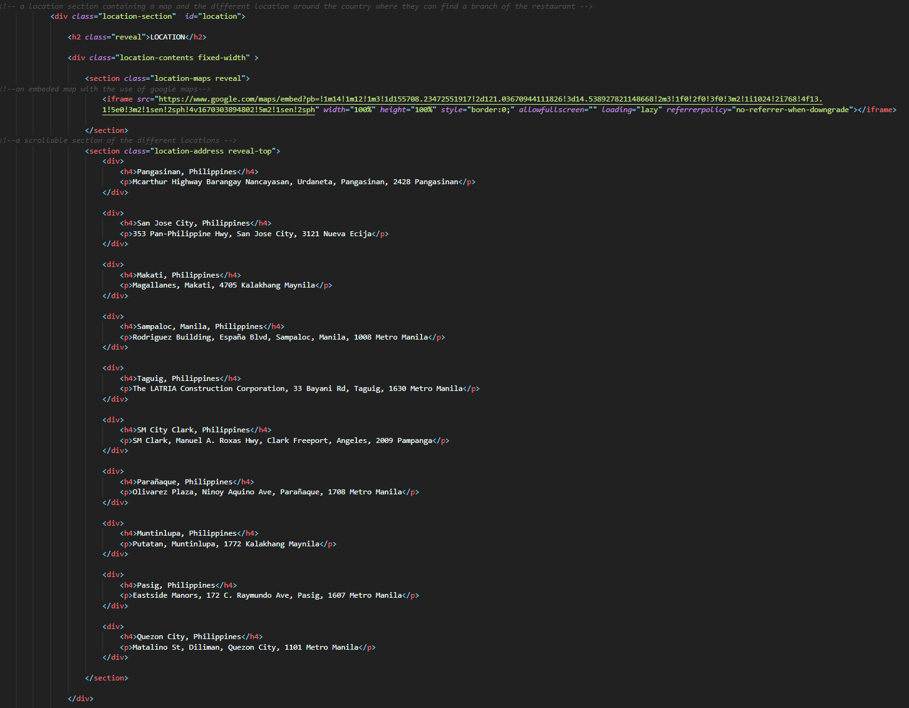

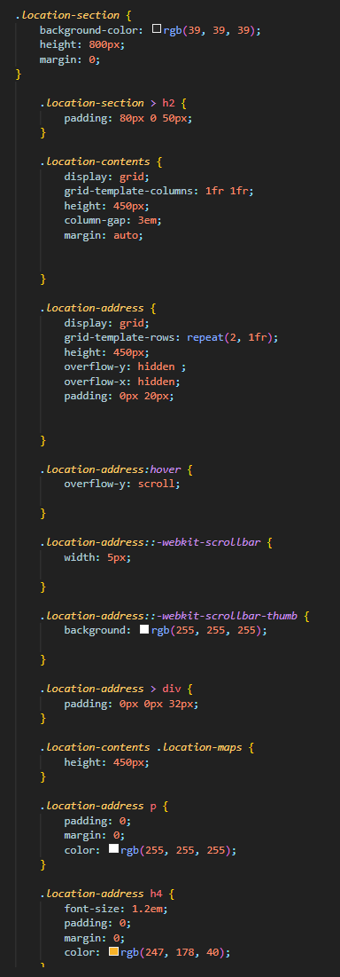

This is the location part of the website. This contains the embedded map through the use of google maps, and a scrollable list of different branch location throughout the country. Uses grid display and overflow scroll for the scroll function of the location list.

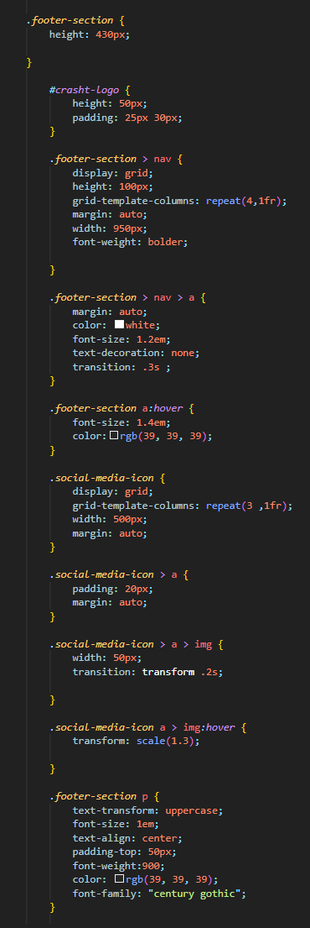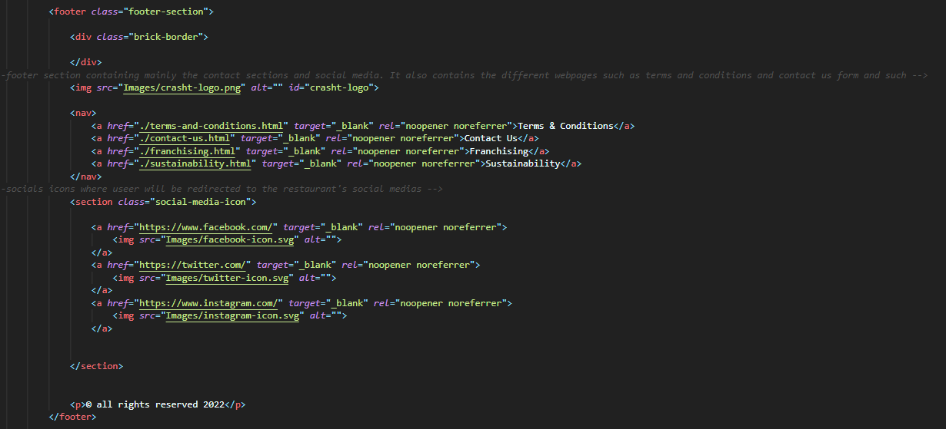**Footer**

The footer section contains most of the webpages connected to the main website. Webpages such as contact us, franchising, terms and condition, and sustainability. It also contains the different social media the pizza parlor has.

**JavaScript**

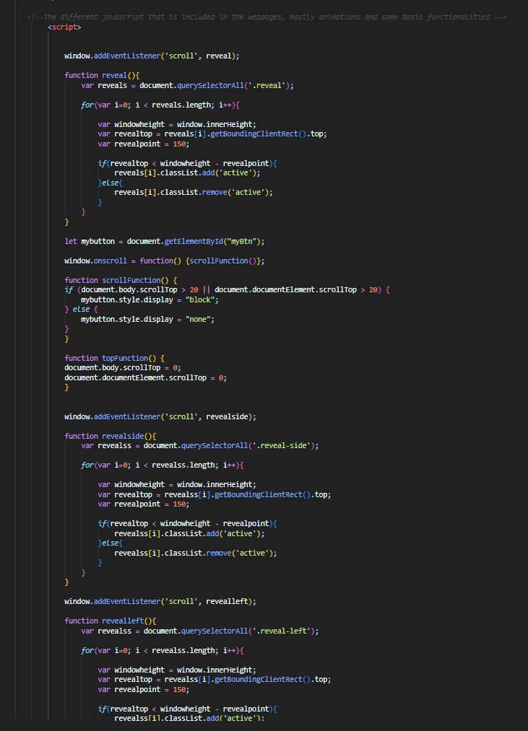

The JavaScript part is not an external file. This is contained in the main body’s section. This are the different javascript functions. Functions such as for the animation, loading animations, transitions, and the jump to top button. These codes combined with CSS achieves a fully responsive and interactive website.

**Responsiveness**

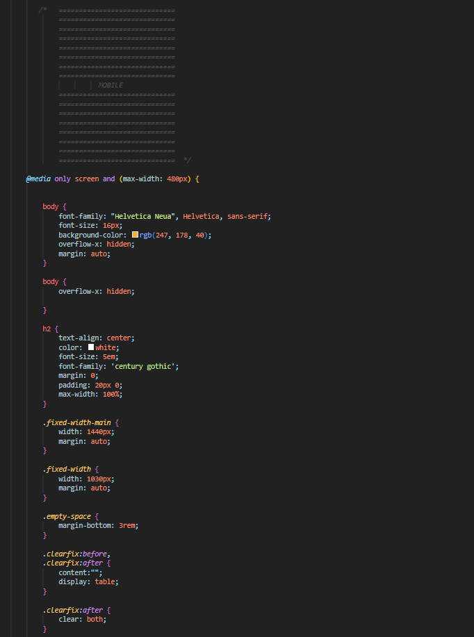

The website is made responsive through the use of @media. This breakpoint allows the website to be redesign and allow for layout arrangement when the viewport is met. The CSS is simply readjusted or rearrange to accommodate for the smaller screen real estate.